Maths Challenge
How many bricks can you put in your hand?  Count them.  Add one more/ less. How many now? | Exercise  Make number cards 1 – 20. Choose a card. If the card chosen is 5, do 5-star jumps.  Try other exercises. | Get a container and fill up. Full, half and empty.   | Use cornflour, sand and flour and practise writing your numbers. | Using claps and clicks create a pattern. Try other ways of making sounds to create new patterns.  
Make shape cards. Hang them around a room or your garden. Listen to the adults instructions: for example – run to the shape with 3 side, skip to the shape with 4 corners. | Measure the adults in your house. Who is the tallest? Who is the shortest? | Can You put numbers 1 to 20 in order?  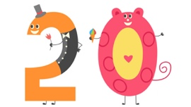 | Make number cards 1 – 20. Hang them around a room or in you garden.  When the adult calls the number skip, run, hop to the number. | Find three objects and measure them using hands and feet.
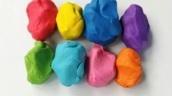  Use Play dough to make the numbers and objects to go with it. | Go and find 5 objects. Who is the quickest?  Count the objects.  Try with different numbers. | Use cornflour, sand and flour and draw your shapes. | Build of tower using 10 bricks.  Challenge yourself and build a bigger tower. | Use Play dough to make different size shapes and sort them  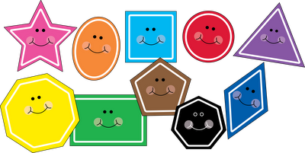
Use four colours to create a repeated pattern. Get you grown-ups to take a picture. | Draw three circles in your garden. Label them with numbers – 1,2,3.  Now throw the object on the numbers.  Add them together. | Line family members in size order.  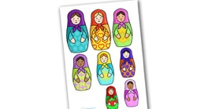 | Collect different items in your home and put them in size order. | Use recycled materials to create a 3d Model.  Name the shapes you have used.
Paint a picture using shapes. | Purple Mash activities. | Sort objects according to their size and shape. | Create a birthday cake with the number of candles to say how old you are. | Use two colours to create a repeated pattern. Get you grown-ups to take a picture.
Maths Challenge

Here are some maths activities for your child to try. Please select the ones that you think they would enjoy. You are not required to complete all the tasks. Don’t forget to share your activities on Tapestry as we would love to celebrate your achievements.

