My Transition Book
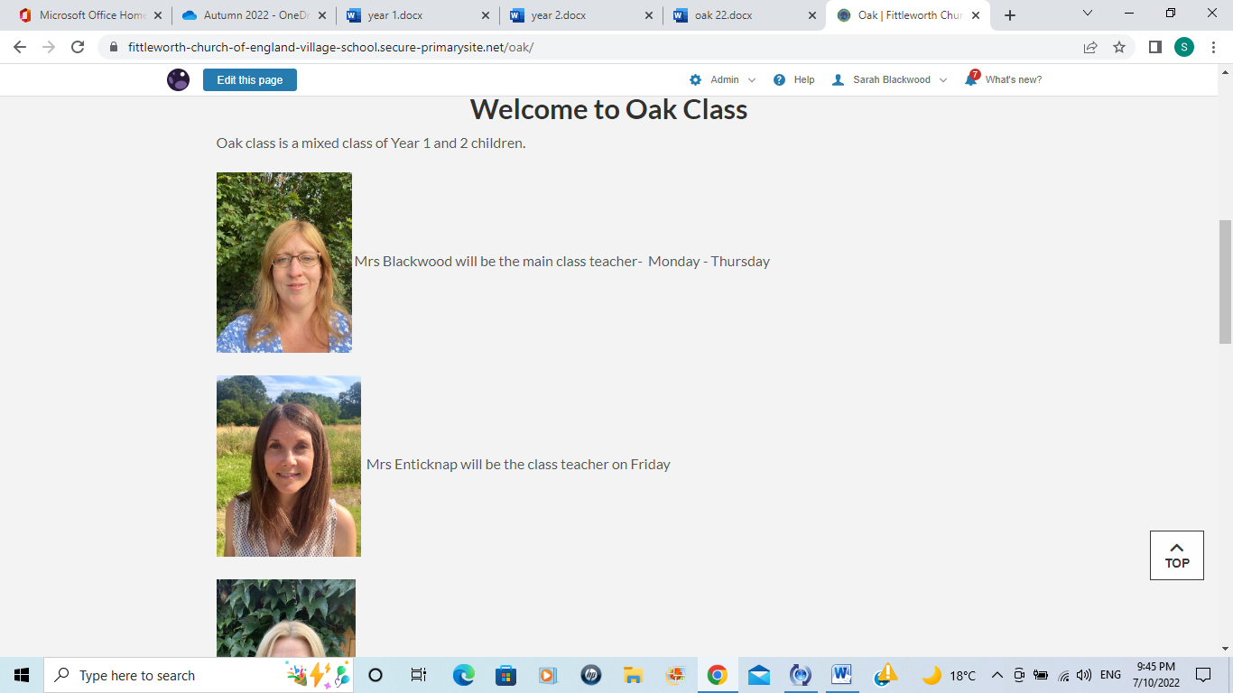
Welcome to Year 1 /2
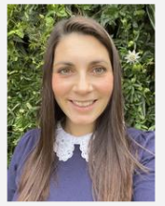

Teachers – Mrs Blackwood, Mrs Enticknap and Mrs McKee

Year 1 and 2 pupils are registered as a Beech/Oak class first thing in the morning at 8.45am and again at 1pm. Year 1 children are predominantly taught as a cohort. See overleaf throughout the day.
Oak teachers are Mrs Blackwood Monday – Thursday
Mrs Enticknap Friday
Beech teachers are Mrs Enticknap Monday – Tuesday
Mrs McKee Wednesday - Friday
Teaching Assistants of year 1 and 2 are Mrs Tudgay, Mrs Barron, Miss Tudgay

This year will be fun and full of learning!
Learning is a partnership between the child, school and home and this is really vital to good progress.
The school website will be updated regularly so please visit and access the games and information added.
Fruit will be provided for Year 1 and 2
PE kits will be worn Monday and Tuesday
Year 2 only - You can bring a suitably sized pencil case that only you use and don’t play with. You need: at least 2 pencils (HB), pencil sharpener, rubber and colouring pencils
This timetable has proved this year to be very successful with the children making good progress and we will continue this format again this year. As the year progresses the year 1 will get less explore and learn sessions and move to a timetable like the year 2.
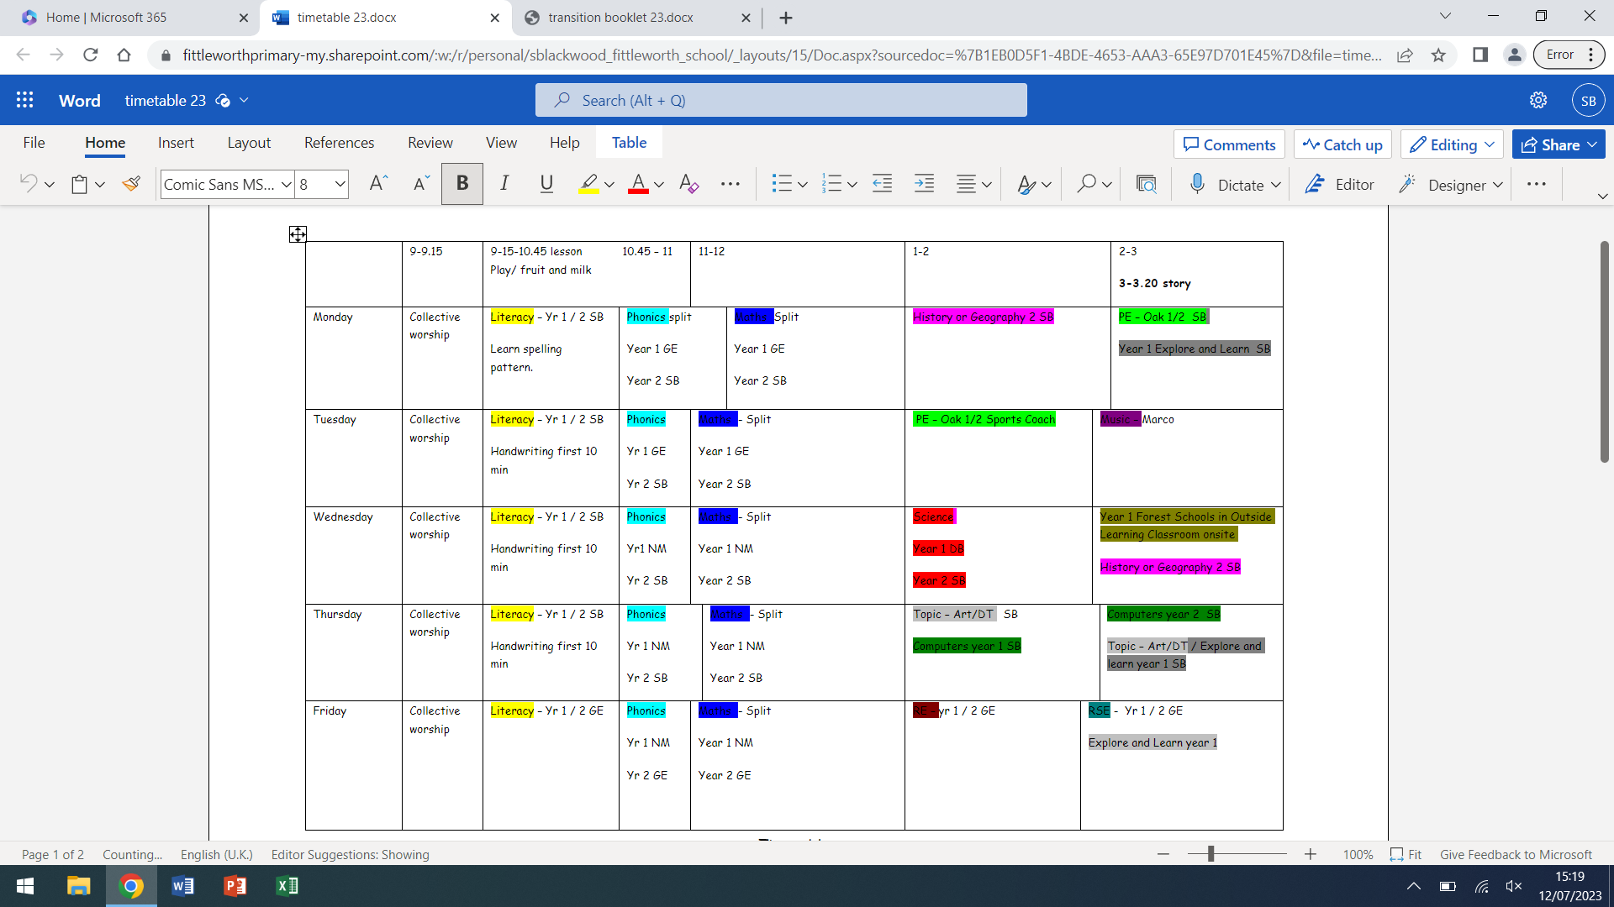
Class Expectations
Organisation
- Reading books and diaries (Everyday) They will be checked daily but only changed on a Monday, Wednesday and Friday
They will have a phonics book and free choice book.
- Spelling activity book (Everyday)
- Named water Bottle (Everyday)
- Wellies to be kept in school and remember a coat.
Independence
- It's never too young to encourage them to pack their own bags
- Bringing their own belongings and taking responsibility for them
- Being independent learners in class and try their best.
- Collecting and carrying their belongings at the end of the day.
Homework
Try to create a quiet and encouraging environment for your child to:
- Read to an adult frequently.
5 A = 5 times to an adult at home, recorded in the diary.
Read the scheme book (colour book) to develop phonics. Enjoy the fun book together to extend their vocabulary and enjoyment of reading. Discuss the books, ask questions and read it again if they want to!
- Practise weekly spellings as well as 1/2 list and phonic practise.
- Purple Mash - logins in reading diary
- Homework – self initiated
- Practise times tables – Year 2’s x10, x2, x5, x3
- Practise telling the time. Year 1 – o'clock and half past. Year 2 also quarter hours and moving onto 5 minute intervals.

